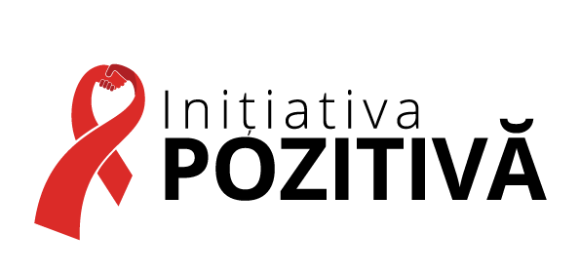
Adresa juridică / sediul: Republica Moldova, Cod fiscal: 1011620006890
MD 2043, mun. Chișinău, str. Independenței, 6/2 Tel.: (+373 22) 00-99-74
Gmail: secretariat.initiativapozitiva@gmail.com Pagină web: www.positivepeople.md

TERMS OF REFERENCE
Assistant for economic empowerment activities

- GENERAL INFORMATION ABOUT THE PROJECT
Public association "Positive Initiative" is an organization of patients living, affected and/or vulnerable to HIV, hepatitis C or tuberculosis, with vast experience in the field of HIV/AIDS and drug addiction, operating all over Moldova.
The organizational goals are:
- Prevention of HIV/AIDS, viral hepatitis C, tuberculosis, drug addiction and other socially dangerous diseases;
- Expansion of access to treatment, care and support in the context of the epidemic of HIV/AIDS, viral hepatitis C, tuberculosis and drug addiction;
- Wide involvement of beneficiaries in decision-making on key issues of combating the epidemic of HIV / AIDS, viral hepatitis C, tuberculosis, drug addiction and other socially dangerous diseases, eliminating their consequences at all levels;
- Strengthening the capacity of beneficiary organizations and communities;
- Contributing to the protection of human rights, etc.
The organization activities are aimed to bring together the efforts of all responsible and interested parties, strengthening community systems by influencing public opinion and community policy, offering to create an environment in which every person, regardless of their level of vulnerability, has all the rights and opportunities for a decent life.
Vision of the association: “We strive for Moldova to become a state in which human life is an absolute value!”
Currently, A.O. „Positive Initiative” within the International Rescue Committee, Inc. (hereafter IRC) partnership agreement from 14.06.2022, signed between IRC and A.O. "Positive Initiative” intends to hire two assistants for economic empowerment activities.

- THE PURPOSE OF THE SERVICES
The purpose of the services is to increase refugees’ access to employment oportunities in Republic of Moldova.

- DESCRIPTION OF ACTIVITIES AND RESPONSIBILITIES
A.O. “Positive Initiative” intends to contract two assistants for economic empowerment activities, which will identify refugees who want to find a job and guide them in the process of integration into the labor market.
- EXPECTED RESULTS
The consultant / expert will be responsible for the provision of the following services:
1. Informing refugees and recruiting them for employment services;
2. Completion of the questionnaire for assessing competencies and skills;
3. Development of a refugee database with the establishment of their occupational profile;
4. Monitoring each refugee in the labor market integration process;
5. Making monthly reports; reporting to the project coordinator.

- REQUIRED EDUCATION AND QUALIFICATIONS
The assistant must have the following qualifications and expertise:
General Qualifications (30%)
- To be a refugee from Ukraine, living in Republic of Moldova;
- To have experience in the field of Human Resources Management.

Relevant experience (60%)
• At least 2 years of experience in the field of human resources management,
• Previous work experience in project coordination, organizational management, or other relevant fields.

Other qualifications (30%)
• Excellent oral and written communication skills;
• Excellent computer skills;
• Sufficient social networking skills.

* The consultant who will accumulate the highest score will be invited to the interview.

- TIMEFRAME OF THE PROVISION OF SERVICES
The selected assistant will assume all the responsibilities set out in this ToR. The duration of the contract is 12 months, with 2 months of probation.
Working conditions are for 50% time (4 hours per day), and the total salary is 650 USD per month. The payment will be made in MDL, after deducting all taxes.
- REPORTING REQUIREMENTS
The assistant will provide a report each month to the project coordinator.

